903 Limos
ninezerothreelimos@yahoo.com
903.292. 8080
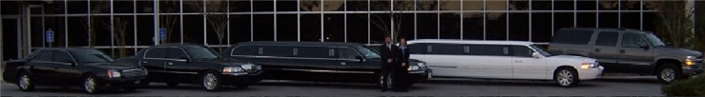

Credit card Authorization Form

Credit card information: (circle one)
American Express Visa Master Card Discover
_______________________________ _________________ ____________
Credit card number expiration date security code on back of card.
Cardholder’s printed name as it appears on credit card: ___________________________________________
Billing Address for Credit Card __________________________________________________
____________________ __________________ _________________
City State Zip Code
Contact Phone Number: ( ) _______________ Reservation # _______________
Base Rate: ___________ Service Charge @ 20 % : _________ Total Charge: _______________
_______________________________________
Authorized Card Holder Signature

I, the undersigned, authorize Nine ZeroThree Limos or B.T. Enterprises to charge the above referenced credit card for transportation, damages and related services. I understand that if a trip is not cancelled within 10 days by Certified Mail or Fax for sedan, limo or bus runs, or if the passenger does not show up for the confirmed
reservation, I will be billed the full amount of the trip.
Please E- mail, Fax or E-Fax back this form with a copy of the front and back of the credit card, as well as a copy of the Drivers License of the authorized person to
E-Fax: (206) 339-6151
Fax: (817) 566-2961.

